SANDBAG PLACEMENT

- Remove any debris from the area where the bags are to be placed.
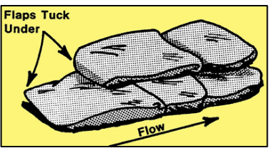
- Fold the open end of the unfilled portion of the bag to form a triangle. If tied bags are used, flatten or flare the tied end.
- Place the partially filled bags lengthwise and parallel to the direction of flow, with the open end facing against the water flow. Tuck the flaps under, keeping the unfilled portion under the weight of the bag.
- Place succeeding bags on top, off-setting by one half (1/2) filled length of the previous bag, and stamp into place to eliminate voids, and form a tight seal.
- Stagger the joint connections when multiple layers are necessary. For unsupported layers over three (3) courses high, use the pyramid placement method.

PYRAMID PLACEMENT METHOD

- The pyramid placement method is used to increase the height of sandbag protection.
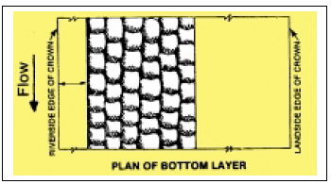
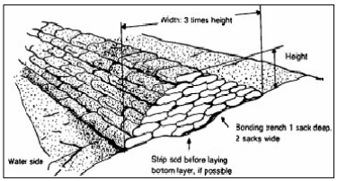
- Place the sandbags to form a pyramid by alternating header courses (bags placed crosswise) and stretcher courses (bags placed lengthwise).
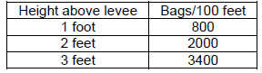
- Stamp each bag into place, overlap sacks, maintain staggered joint placement, and tuck in any loose ends.

Ringing boils
A boil is a condition where water flowsthrough or under an earth structure (such as a levee) that is retaining water. Free flowing water wants to move to lower elevations. If a levee is stopping floodwaters, the water may be able to find weak points to enter. This action is called "piping". If the water finds a large enough path, the flow will become visible, and is a serious threat to the integrity of the levee. Most boils occur in sand, silt, or some combination.
A boil is found on the landward side of the levee, or in the ground past the levee toe (the exact distance varies with local conditions). Possible boil sites can be identified by free standing or flowing water (other than culverts, pumps, etc). A boil can be found only by close inspection. A prime indicator is water bubbling (or "boiling"), much like a natural spring. Another is obvious water movement in what appears to be standing water.
Carefully examine the water for movement. Boils will have an obvious exit (such as a rodent hole), but the water may be cloudy from siltation, or the hole very small. If there is any movement in the water, carefully approach the site, disturbing the water as little as possible. Let the water settle, and look at the suspected site. If you see the hole, examine it carefully. If the water flow is clear, there are no problems as yet. If there is no distinct hole, the water flow is not a threat. Monitor the site regularly for changes, and take no other actions.
A dirty water flow indicates that the soil is being eroded by the water, and that could mean failure of the levee. A boil ring is the best solution. The idea is to reduce the water flow until the water is flowing clear, but not to stop the water flow. This acts as a relief valve for the water pressure; the water continues to flow, but is not eroding the material. If the water flow is stopped, the pressure will remain, and another boil will form.
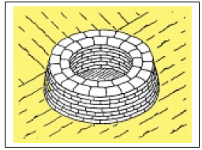
Ring the boil with sandbags, with the first bags back 1-2 feet from the boil. More, if the soil is unstable. Build the first layer in a circle, 2-4 bags across, and then build up, bringing each layer in. If possible, keep the interior face straight. Build the ring wall with the means for water to flow out, leaving a gap in the wall, or using pipes. Adjust the flows until the water slows, and becomes clear. Monitor the ring wall constantly. Raise or lower the height of the wall as necessary, maintaining a slow, clear flow. The height should be only enough to create enough head to slow flow so that no more material is displaced, and the water runs clear.

